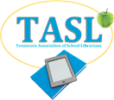
Frequently Asked Questions about TASL Conference
What does basic registration include?
Basic registration includes access to the exhibit hall and the vendor reception with heavy hors d'oeuvres on Sunday evening; access to the exhibit hall, breakout sessions, and our annual business luncheon meeting/keynote (lunch provided) on Monday; and breakout sessions and an additional keynote session on Tuesday. You will also receive a conference bag with professional goodies and a name badge. Note: VSBA Banquet tickets and preconference sessions are not included in basic registration.
What is the VSBA Banquet?
The VSBA Banquet is a delightful evening of celebration. You will enjoy a sit-down banquet style meal and hear keynotes from winning Volunteer State Book Award authors. This is also when we honor fellow librarians, support staff, and administrators who have won TASL Awards this year. The cost of this event is not included in basic registration. Tickets are availble on the conference website. Please order your ticket(s) in advance because we do have limited seating.
What are preconference sessions?
These are add-on sessions on Sunday afternoon before the conference officially begins. They are not included in basic registration. Tickets are available on the Conference website. Please register in advance, because seats are limited!
What meals are included?
If you stay at the conference hotel, you get a complimentary breakfast each day. On Sunday, you may enjoy the Vendor Reception with a buffet. On Monday, lunch is served at the business meeting. If you choose to purchase tickets to the VSBA banquet on Monday evening, a full banquet-style meal will be served.

Where can I see the conference schedule?
You will receive a program in your conference bag upon arrival, and the Sched conference website will be available to you a few weeks prior to the conference.
Do you have Wi-Fi?
Wi-fi is available this year!
How do I get a book signed by my favorite author?
Check the program schedule for signing times and locations. Due to time constraints and the authors’ contractual agreements with TASL, authors cannot sign during sessions. Please be courteous and use the allotted signing times. Most titles will be available for purchase in the TASL Bookstore.
I registered and paid for conference. How can I get a receipt?
Any form transaction you submit on the TASL website creates a receipt, and automatically sends a copy to the email address in your TASL profile. If you think you did not receive this receipt, it is most likely in your Junk email folder. If you are unable to locate it, you should log into your TASL profile, hover over the gray My Profile tab, select View Transactions, click the Receipt icon beside the event registration, and click Print Receipt.
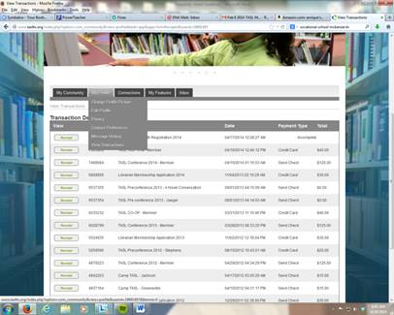
Will I get a Certificate of Attendance?
Yes! COAs will be available at the close of conference on Tuesday in exchange for your completed conference evaluation. Because we cannot monitor attendance each session, there is a checklist on the reverse of your certificate for you to record your attendance.
I’ve just realized I am double-booked and will not be able to attend conference. Can I get a refund?
Our cancellation policy appears on the online registration form and can be found on your confirmation/receipt. Each member must acknowledge agreement to the cancellation policy prior to completing their registration. That policy is: Upon written request, refunds and cancellations, less a $20.00 handling charge, will be honored if postmarked no later than August 28, 2017.

