TASLCON2019 Sample Budget Worksheet

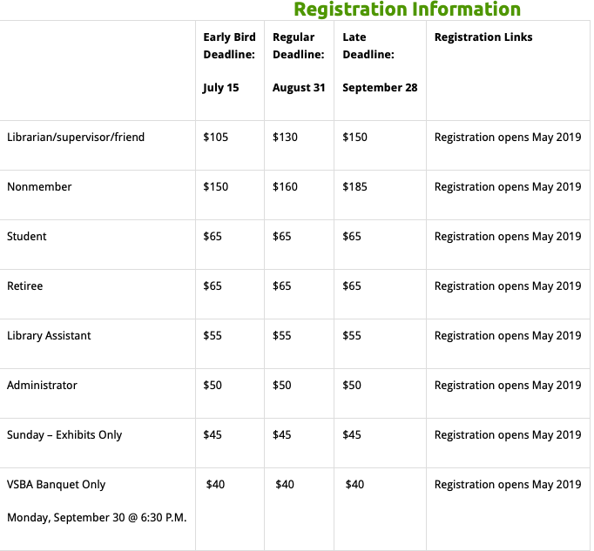
Registration Cost
*Early bird registration fee expires on July 15, 2019
Hotel Costs (Embassy Suites rate for the conference is $155/ night.)
Pre-conference sessions (*see below)
Mileage reimbursement
(Check with your bookkeeper for the rate.)
(____miles x ___ per mile)
VSBA Banquet | 40.00
TOTAL

